July 2010
Issue 11
Safety Matters

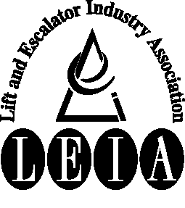
Articles:

• Industry Accidents 2009

• Pit Ladder

• Silica dust

• Safe & Sound safety campaign

Tel: 020 7935 3013
Fax: 020 7935 3321
Email: enquiries@leia.co.uk
Website : www.leia.co.uk
Welcome to the July 2010 edition of Safety Matters.
Through this newsletter our aim is to inform you of health and safety issues that may have an impact on the Lift & Escalator industry. Safety Matters is also available for download from the LEIA member’s website. www.leia.co.uk

Introduction

Industry Accidents 2009

Unsecured ladders and falls from stepladders were implicated in several of the accidents. Falls from height can easily result in major or fatal injury so if there are any doubts about ladders or other equipment for work at height refer to your company using your own procedure.

LEIA is a member of the Specialist Engineering Contractors (SEC) Group that consists of a number of industries similar to the lift industry. Comparing the lift industry statistics with SEC there are less manual handling accidents (7%) but slightly higher (2%) slip, trip and fall accidents. This difference is thought to be due to the different working environment each industry operates in.

LEIA statistics are also higher than SEC (3%) for falls from height, this should be seen as a timely reminder of the dangers of work at height. As stated earlier ‘if there is any doubt about a work situation or equipment check with your company’
There were a total of 121 accidents reported to LEIA by 106 companies within the UK lift industry during 2009. The accidents were all RIDDOR reportable, 108 being where the accident resulted in an absence of more than 3 days from work and the remaining 13 being major injuries, which include fractures.

The greatest cause of accidents (26) was Manual Handling. The majority of the accidents resulted in back injuries (strains and sprains) while lifting or moving loads. Other injuries caused by manual handling were cuts from sharp edges and fractures to fingers.

Several accidents resulting from a Slip, Trip or Fall on same level (25) were caused by snow, ice and other slippery surfaces. Slipping on stairs, ladders and the lift car top also resulted in accidents in this category.

There were 14 falls from height during 2009 of which 4 resulted in major injury.

Accident Awareness
Engineer seriously injured when he fell off pit ladder

A lift service engineer was attending a call out to carry out a repair. During the repair process the engineer had to enter the pit to access the damaged landing door shoe.

The lift car had been put on inspection and the car top stop switch into the stop position before entering the pit.

The pit was accessed by climbing down the pit ladder but the engineer failed to remove it from its storage position on the wall and position it in the correct position for accessing and egressing the pit.

During the repair procedure the engineer climbed up the pit ladder to manually open the landing doors. When climbing back down the ladder the storage bolt that the ladder was positioned on came away from the wall and the engineer fell off the ladder approximately a metre to the pit floor.

The injuries he received were fractures to his leg and ankle.

Always ensure ladders are in a safe working position before using them.

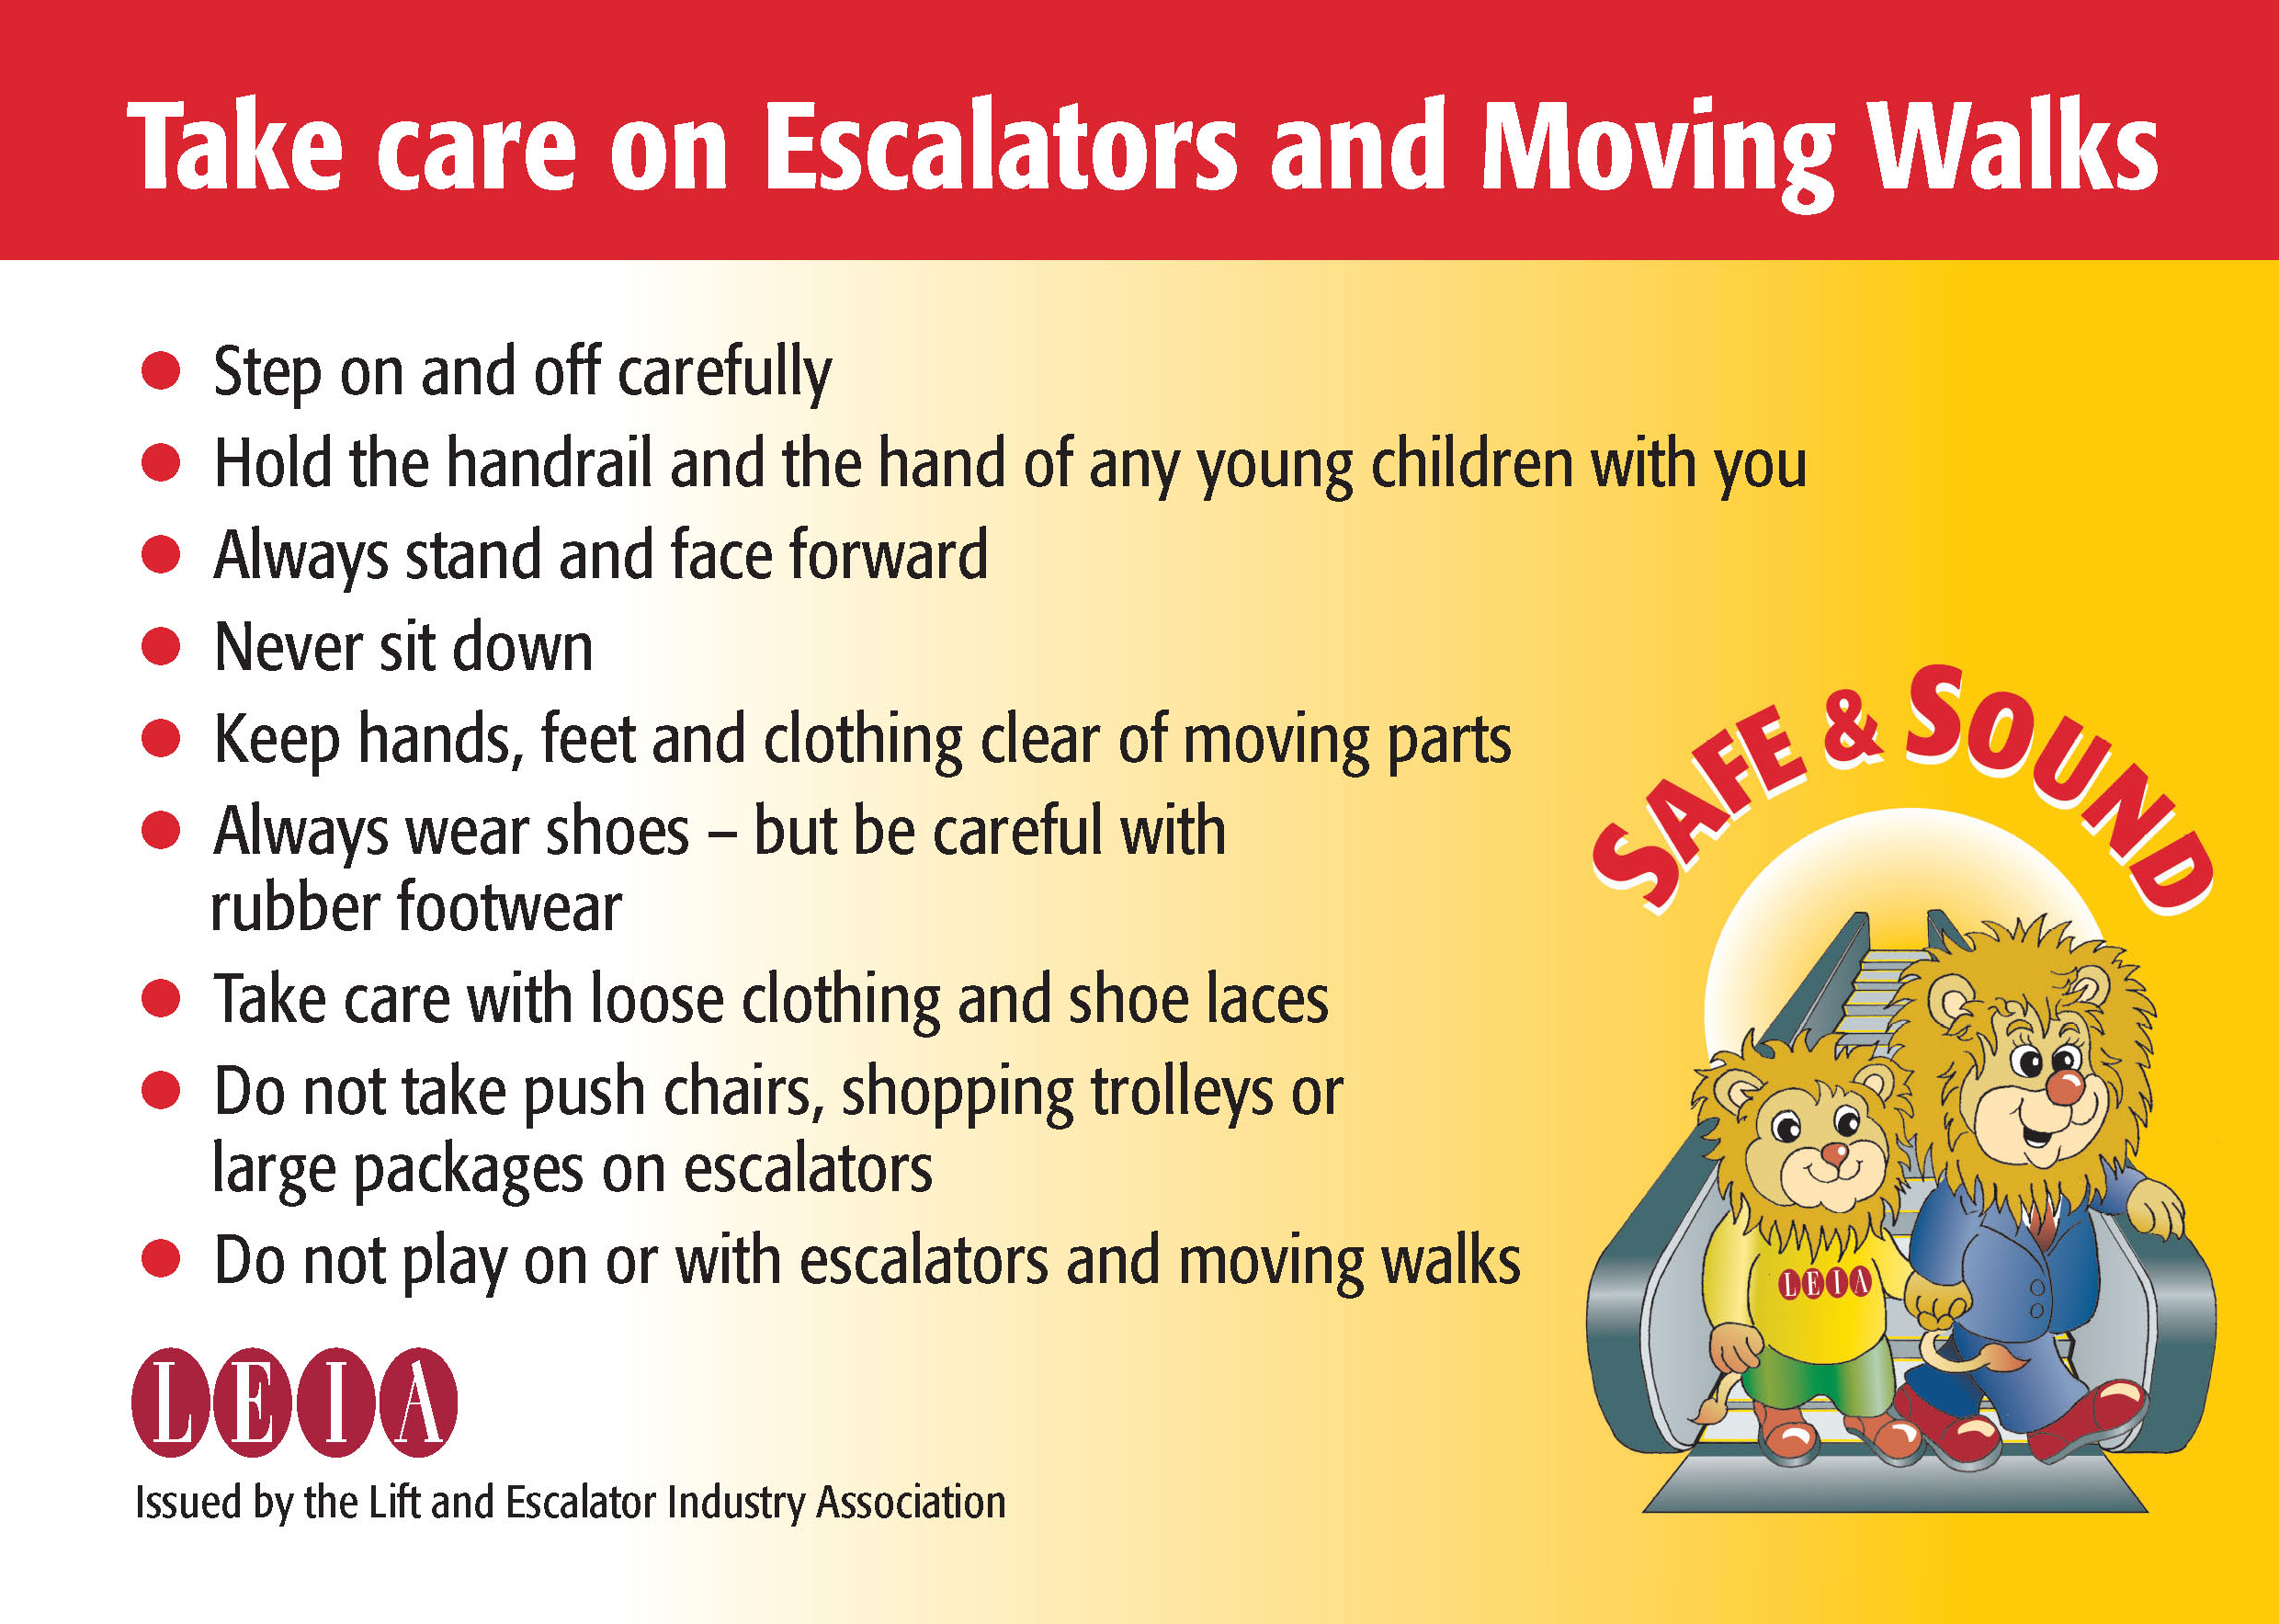
To promote the safe use of escalators and moving walks LEIA has launched a poster and card campaign outlining safety messages when using the equipment.

The card featured is aimed primarily at young children and their parents by featuring two characters ‘Safe & Sound’ and sends the message that escalators and moving walks are not a playground.

The Safe & Sound campaign reminds everyone that misuse carries the risk of serious injury.

As well as the cards posters are available on the LEIA website to print off. Cards are a small A6 size and can be requested through LEIA at no charge.

Escalator Safety – Safe & Sound

CoSHH - Silica
When the term CoSHH is raised hazardous substances such as oil, paint and chemicals come to mind but CoSHH covers a wide range of items including general nuisance dust and dust that may contain hazardous materials. The best know example is asbestos which is closely controlled by its own regulations. Another hazardous dust is silica which is present in building materials such as cement and brick dust. Exposure to respirable (breathable) crystalline silica over long term or at high concentration can result in a respiratory disease know as Silicosis.

In the lift industry exposure to silica is most likely to occur when drilling into concrete, brickwork or blockwork. It may however also occur where other activities are being carried out on site such as cutting of concrete or brickwork, demolition of concrete and brick structures and general cleaning and removal of rubble where dust suppression (damping down) is not used or where ventilation is poor.

Whatever PPE (or other controls) have been put in place by your company, for example a disposable respirator, as a result of a risk assessment it must be used, and any procedures defined in instructions or method statements must be followed.
CSCS – Safety Test

When renewing a CSCS card there is a requirement to successfully pass a touch screen health and safety test at a pre-arranged centre. The test is usually arranged by phone through a centralised centre. We have become aware of cases where the wrong test has been advised by the centre which may causes problems later and lead to extra cost to retake the test. If you are taking a lift, escalator, tester, stairlift, service lift, or lifting platform health & safety test it should be the lift/escalator specialist test and not the general CSCS test. Check this when booking.

